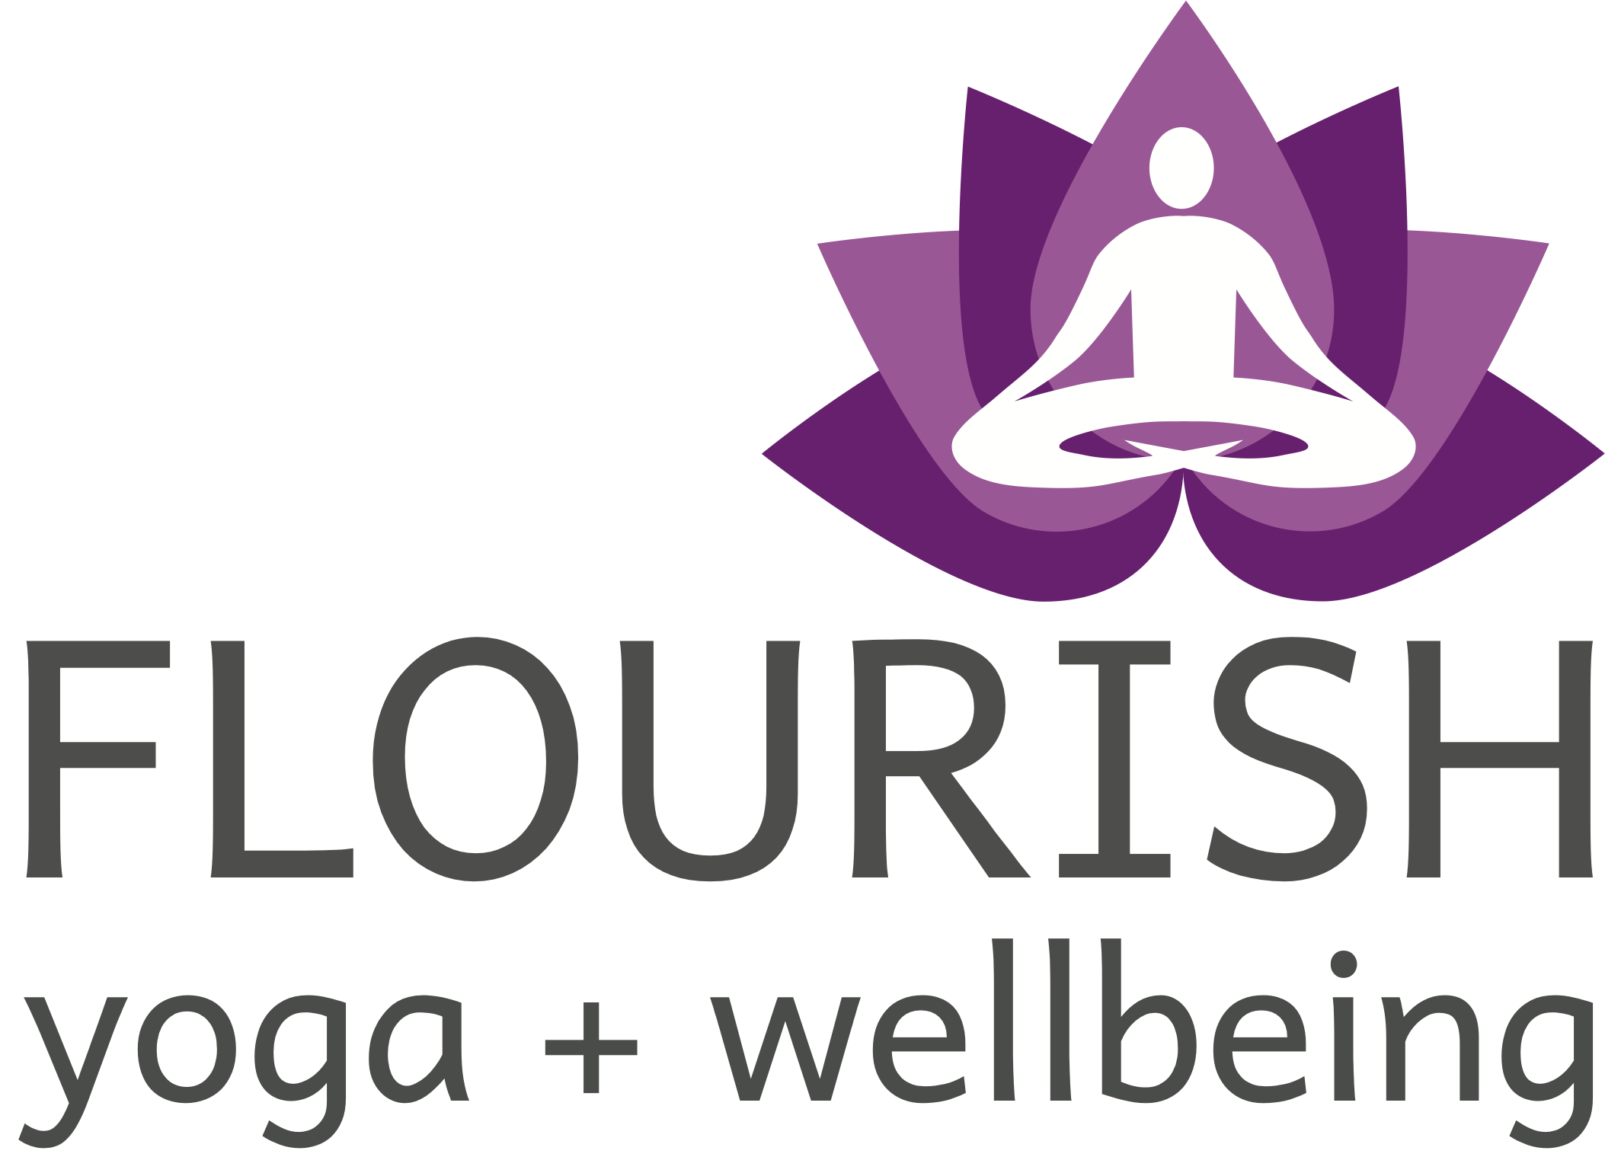

2023-25 300hr Yoga Teacher Training Application

Thank you for your interest in our upcoming 300 hr YTT program! Please print or scan this application and either mail, drop off or email to the studio at your earliest convenience. All applications are due no later than July 24, 2023.. Class size is limited for this training and all applications will be considered on an “as received” basis.

Please include $300 application fee with your completed application. If accepted, the application fee will be credited toward your YTT fee balance.

Incomplete applications may be returned, so please be as thorough as possible with your responses – we want to make sure our training is a good fit for you! Feel free to add space/attach additional sheets of paper for your answers.

Personal Information

Name:________________________________________ Date of birth:____________________________

Address:_______________________________________________________________________________

______________________________________________________________________________________

Phone: Home____________________Work:_____________________Cell:_________________________

Email:__________________________________________ Occupation:____________________________

Emergency Contact______________________________________________________________________

Medical History

It is important to provide relevant medical history with your teacher in case of emergency or special considerations. This information will not be shared. Please give a description of your current health and include any events in the recent past that may be relevant to your health.

1 - Do you suffer from any chronic conditions? Do you for see any issues that would prevent you from participating or modifying your practice to participate in this training?

2 - Is there anything else we should know regarding your medical history or current health?

Your yoga experience

1 - What style of yoga do you usually practice and for how long have you been practicing? Who are some of the teachers you practice(d) with?

2 - Do you have a home practice/study? If so, describe what it constitutes and for how long?

3 - Do you practice forms of meditation and/or pranayama? If so, for how long and how regularly?

4 - What are you currently working on in your asana practice?

5 - What are you working on in your self study? What are some of your favorite books regarding yoga?

6 - What are some of your expectations regarding this training? What do you hope to achieve?

7 - Are there any specific areas of study that you find especially interesting within the yoga realm where you would like to spend extra time in self-directed study? (restorative, yin, kids, etc.)

Contact Erin Smith @317-413-1791 or at erinsmith11@aol.com to make arrangements for application and deposit drop off, or email the application to us at: info@flourishyoga.biz. Please note that emailed applications will not be considered without the accompanying $300 application fee – we appreciate your understanding and cooperation!

